Names: Kevin Andor Scutaru, Nathaniel Dehart, Cole Stewart

CSC 360 Assignment 1

# 33 1/3 points each

1. Prove, by induction, that in a non-empty binary tree of ‘n’ nodes, there are ‘n + 1’ NULL downward links.

Definition: There are 2 links for every node, n (# of links = 2n)

Definition: For every n node there are (n-1) connected links

2(n) – (n – 1) = n + 1; The # of links minus the total # of connected links is equal to the total number of NULL links

Base Case: Let n = 1. The equation holds as 2 = 2. Thus, a binary tree with 1 node has 2 null downward links.  The property holds.

Inductive Hypothesis: Assume n for n = 1, n = 2, …, n = k

Inductive Step: Prove that the equation holds true for n = k+1

2(k+1) – (k+1 – 1) (Distribute the minus sign)

2(k+1) – (k+1) + 1 (Subtract (k+1) from 2(k+1))

(k+1)+1 = n+1 (Proof is complete)

Therefore, for every n nodes there are n+1 NULL downward links

1. Prove the following by induction:

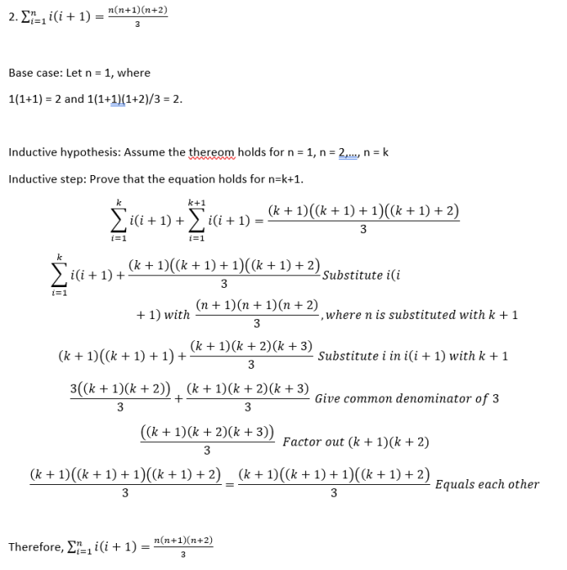

1. Prove by contradiction: if n is a positive integer and n is odd, then n2 is odd

Suppose by way of contradiction that n is an odd number, and n^2 is even

Assume that n is odd:

n = 2k + 1 for some k

n^2 = (2k + 1)^2

= (2k + 1)(2k + 1) (Multiply (2k + 1) by (2k + 1))

= 4k^2 + 2k + 1 (Factor out the 2)

= 2 (2k^2 + k) + 1

Let j be some integer: j = 2k^2 + k

Then n^2 = 2j + 1, which abides by the definition of an odd number.

n^2 is not an even number, therefore the original claim must be true.